Intro to the Momentum Transfer Model (MTM): Part III
- Choose one of the momentum video clips and download it from the S: Drive.
- Import the video clip into LoggerPro and do the frame by frame video analysis for 1st one object and then the other.
- Don’t forget to set the scale and do the analysis (best fit line).
- Sketch the velocity in the x dimensions below:
Object 1: velocity vs. time in the x-dimension (v vs. t)
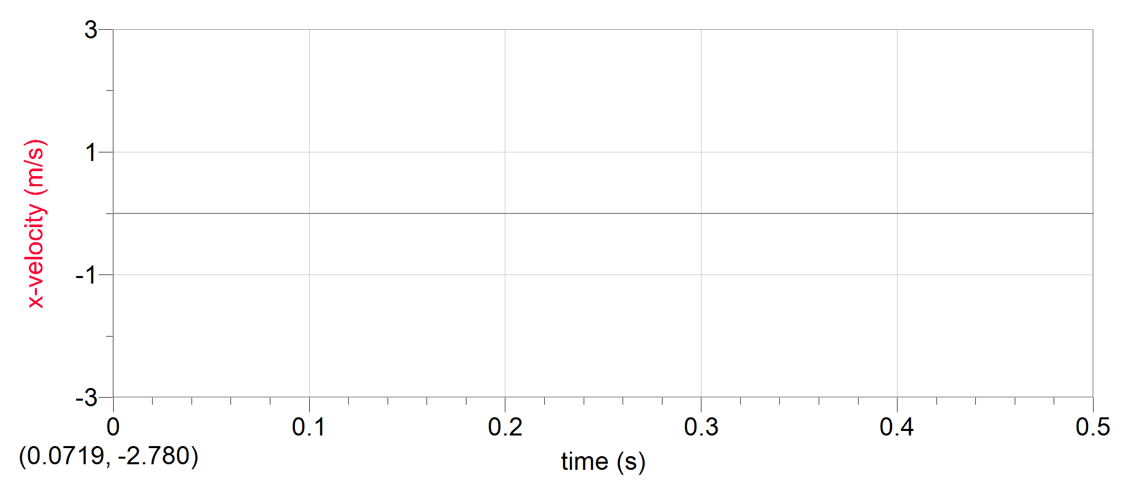
Object 2: velocity vs. time in the x-dimension (v vs. t)

- Record the masses of the two objects provided in the title screen. Convert to kg.

Object 1: Object 2:
The momentum (p) of an object is directly proportional to both the mass (m) and velocity (v) as defined by the equation p = mv. The units are kg m/s.
- Calculate the initial momentum for the each object (p_{i1}) and (p_{i2}) if they are separate or together (p_{i1+2}).

p_{i1} = p_{i2} =

g) Calculate the final momentum for the each object (p_{f1}) and (p_{f2}) if they are separate or together (p_{f1+2}).
p_{f1} = p_{f2} =

- What do you observe about the momentum of the objects before and after the collision?

- What do you observe about the total momentum of the system?

- Summarize the principle you think is outlined in this experiment.

- Create a whiteboard that summarizes the results of your analysis. Use the handout to create the IF charts that go with your experiment. Include a) sketch of the collision before and after b) the calculations c) comparison of the total momenta before and after d) a statement that summarizes the lessons learned.

